**Production order confirmation CO11N Validation for Header Material (101 Movement)**

**Test data-1)- Production order 120005423**

**Step-1)** Order confirmation trying without Header Material, System should not allow confirmation & Give Error message.

**Step- 1.1) Operation 10 Confirmation-** Operation 10 should allow, as in this there is **no Header** material.

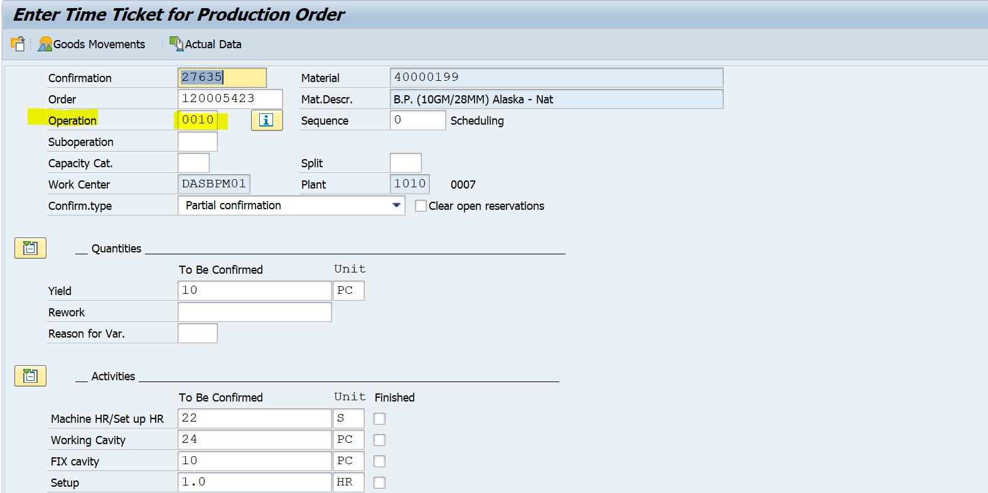

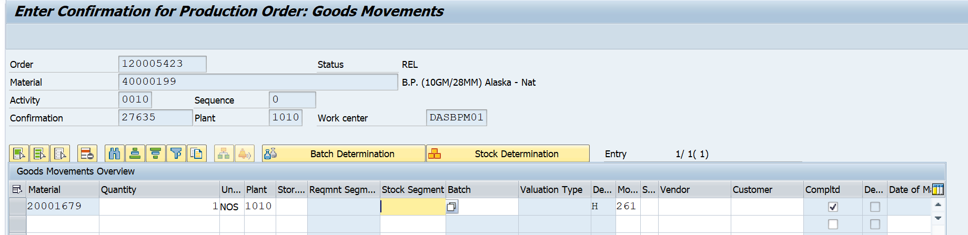



**Step- 1.2) Operation 20 Confirmation- Should allow only if having Header material (101) In Goods movement**

1. **Trying without Header Material**

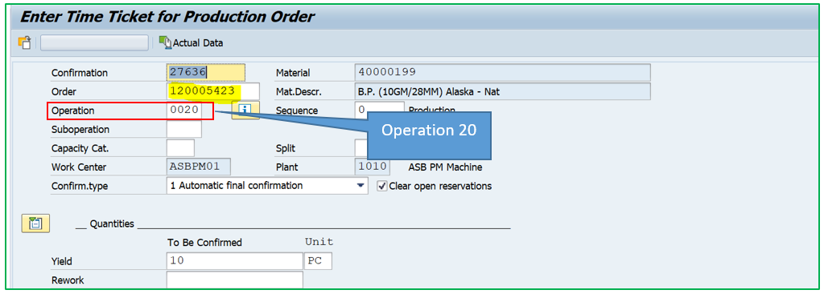

**Deleting Header material 40000199 i.e. 101 Movement in Goods movement**

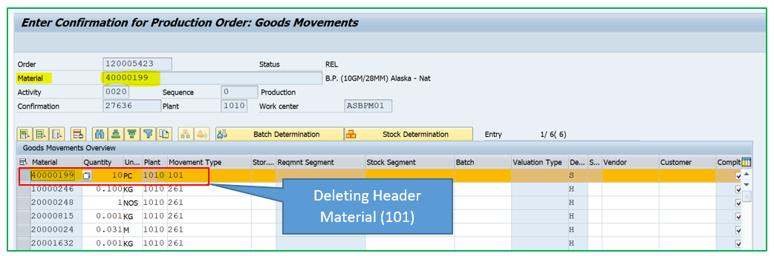

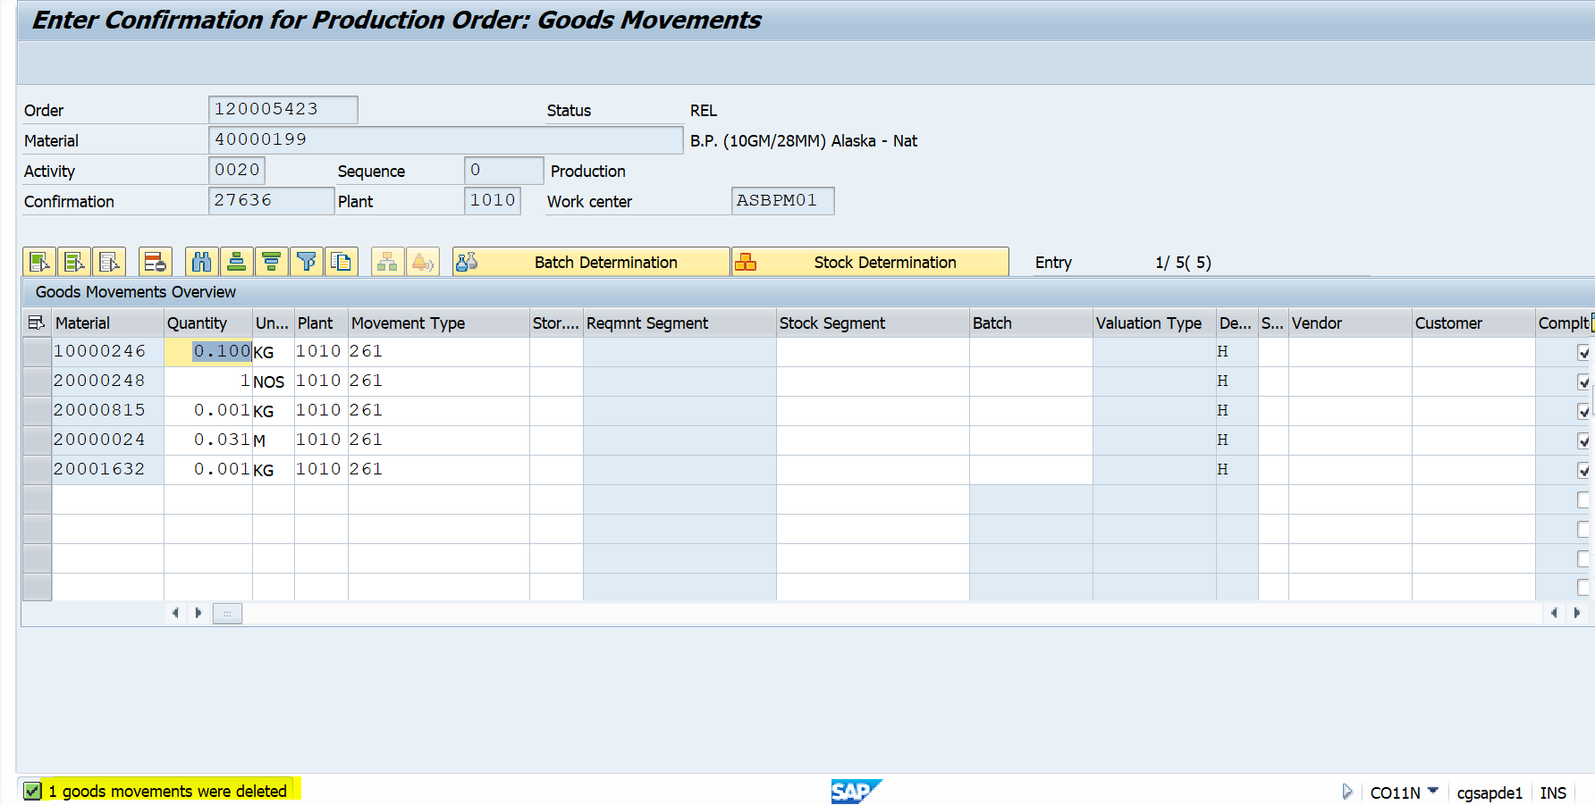

Now if trying to save, system should not allow to save & give error Message **“Header Material missing for Goods Receipt 101”.**

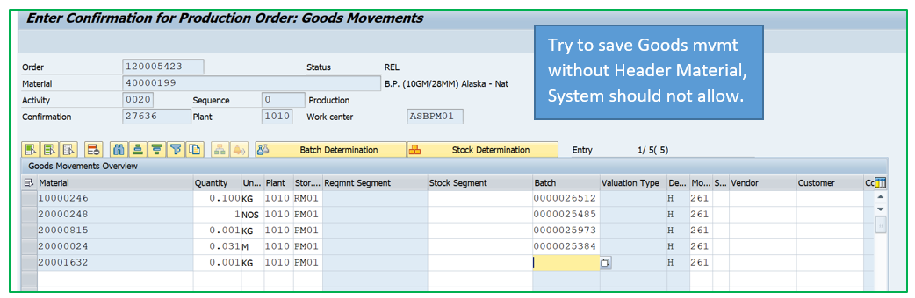

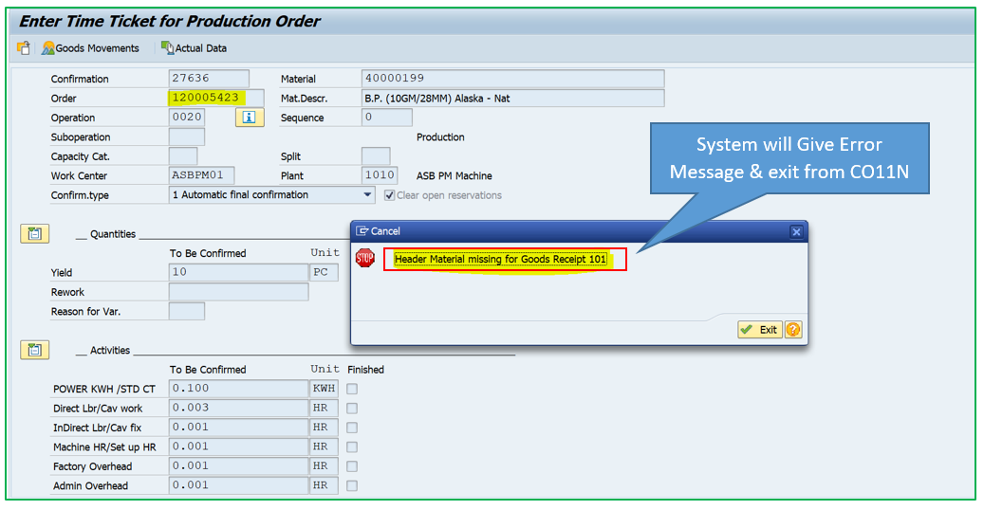

Production order- Opeartion-20 is not confirmed.

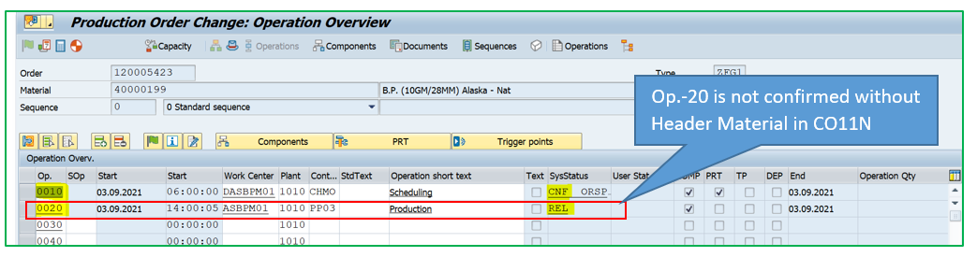

1. **Trying with Header Material**

Now trying Confirmation in CO11N with Header material (101)

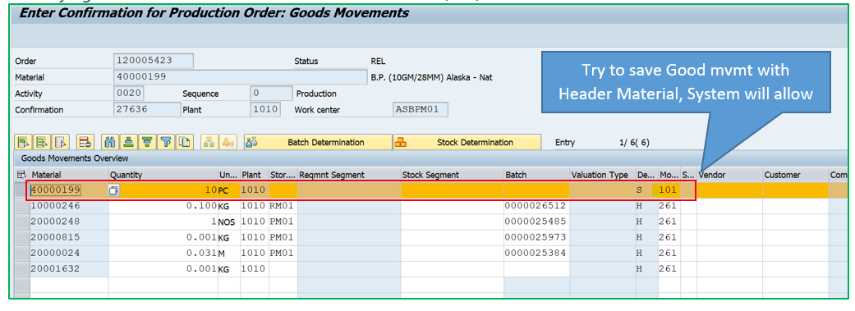

Allow to post & save confirmation.



Production order- Opeartion-20 is confirmed.

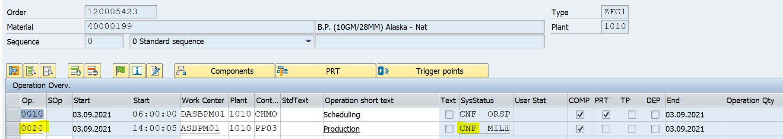

**Test data-2)- Production order 120005424**

1. **Trying without Header Material**

Trying Confirmation for operation-20 without 101 movement of Header material

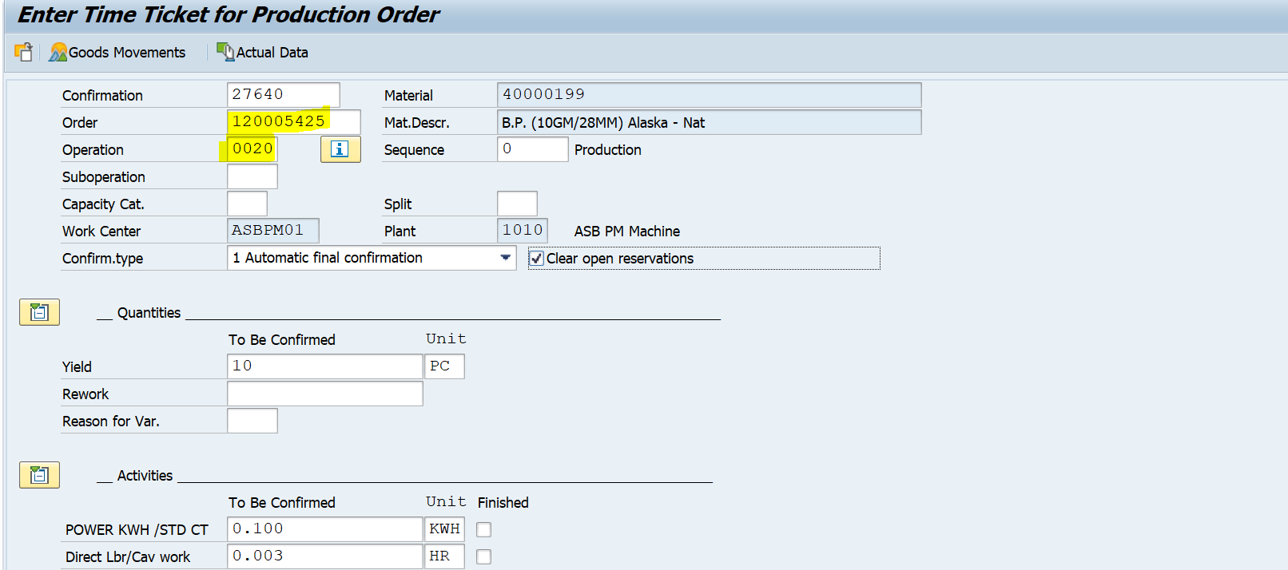

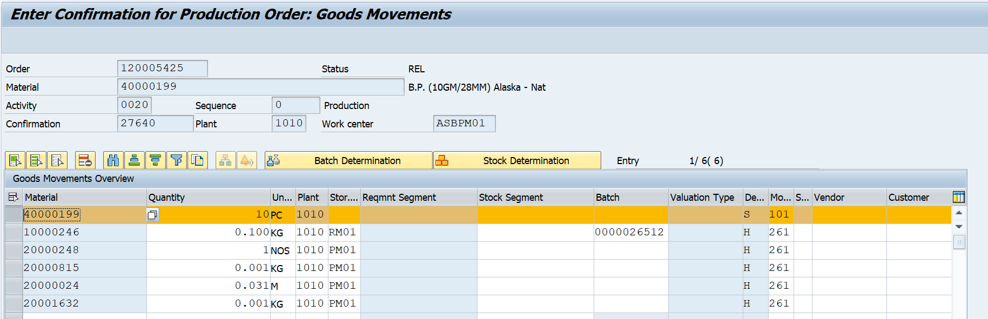

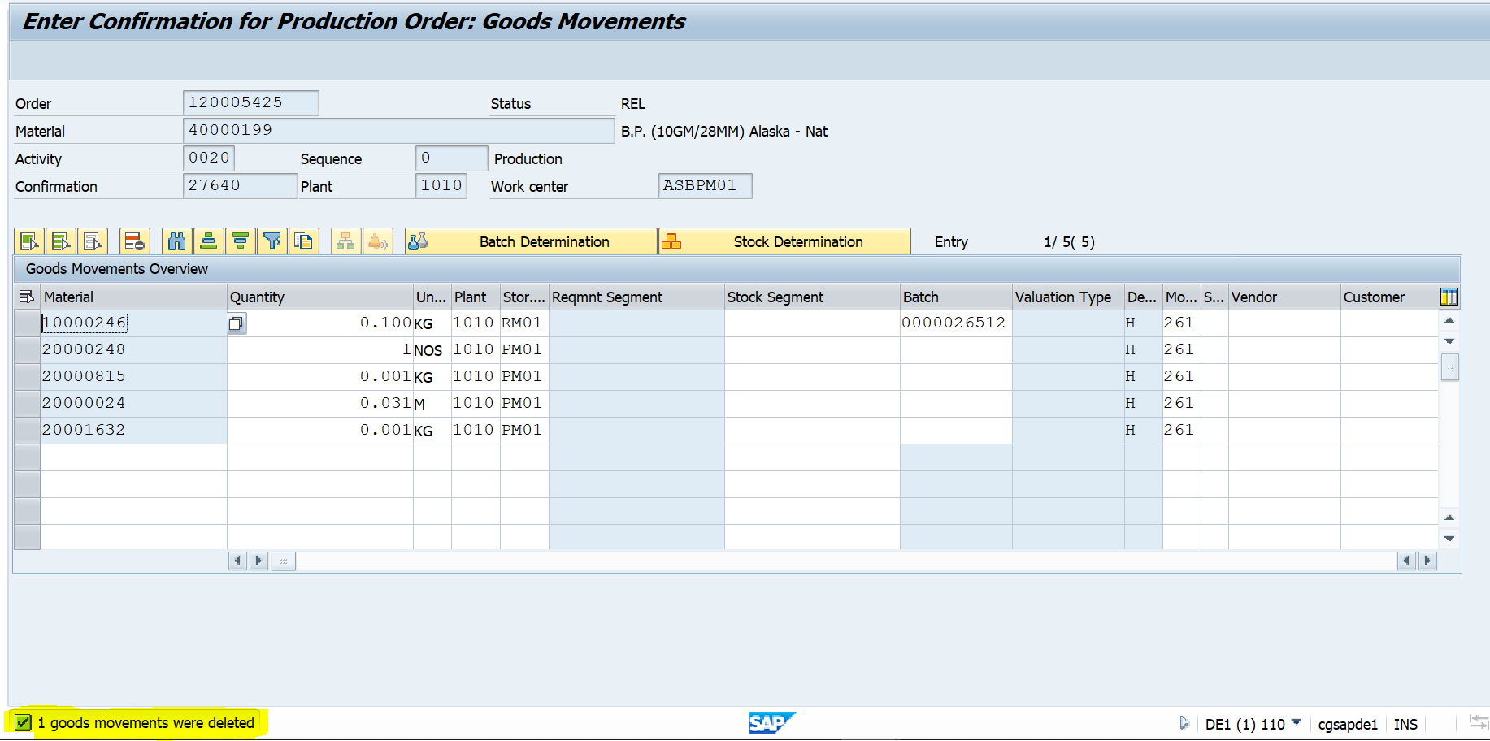

If you try to save, Error will give & exit from confirmation

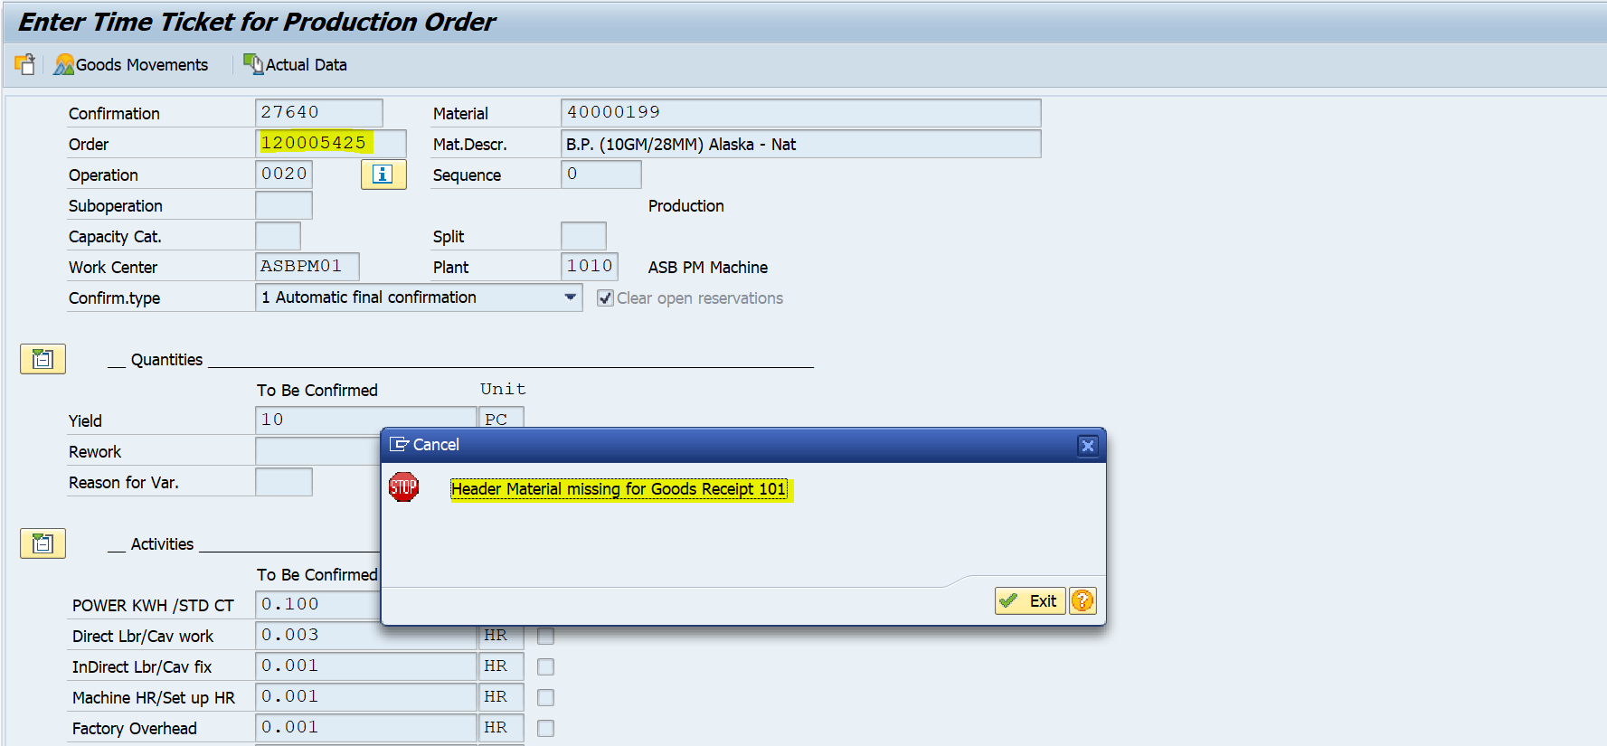

Production order operation 10 confirmed but 20 not confirmed yet.

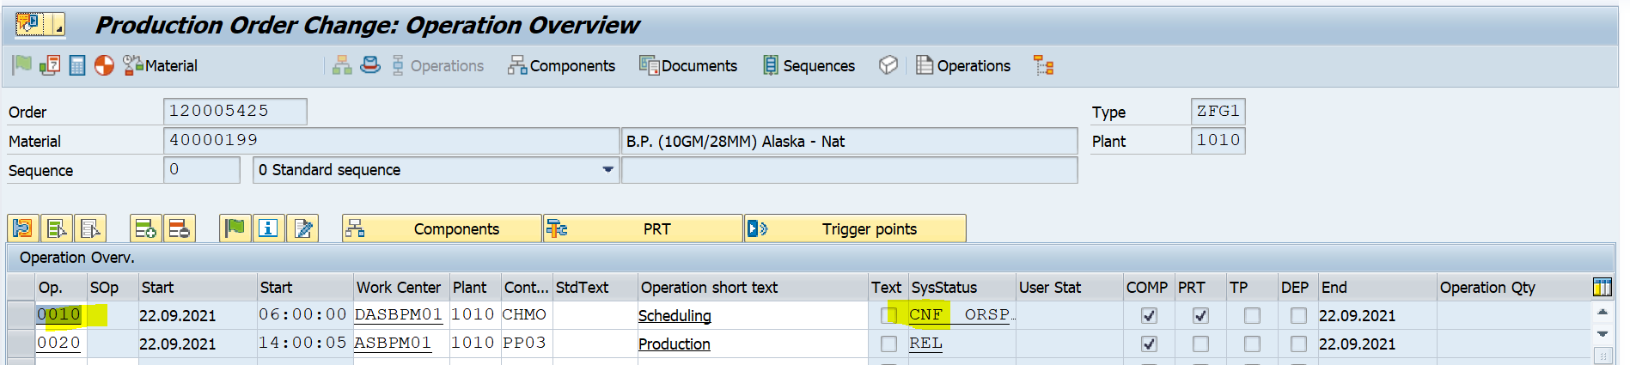

1. **Trying Confirmation with Header Material**

Now trying Confirmation in CO11N with Header material (101)

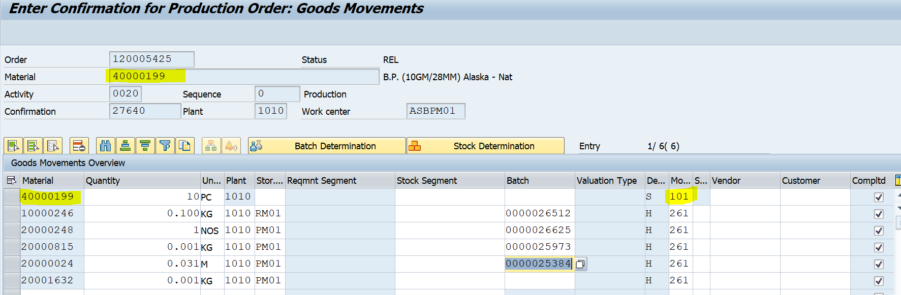



Production order- GR (101) done & operation -20 also confirmed

